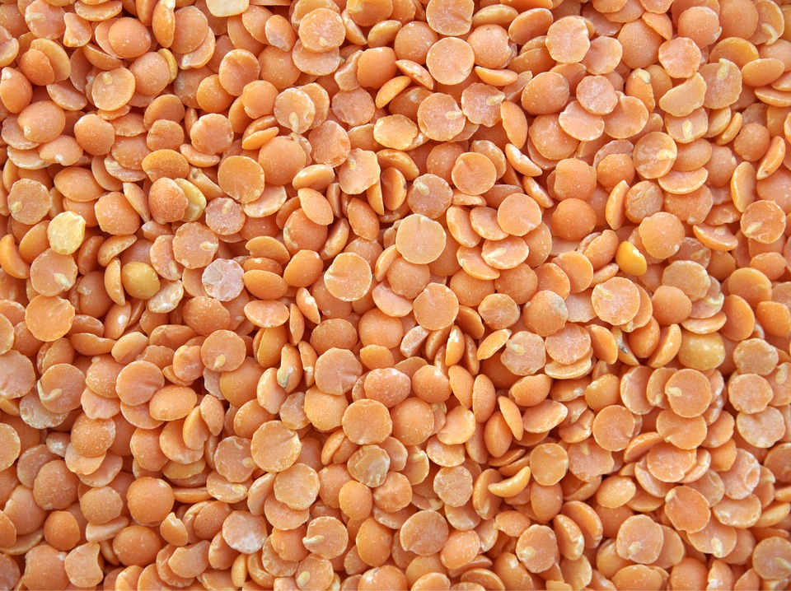
Was Haben Linsen mit Esau und Jakob zu Tun?
Finde es heraus!

________________________________________________________________________________________________________________________________________________________________________________________________________________________________________________________________________________________________________________________________________________________________________________________________________________________________________________________________________________________________________________________________________________________________________________________________________________________________________________________________________________

