Martin Luther
3.5
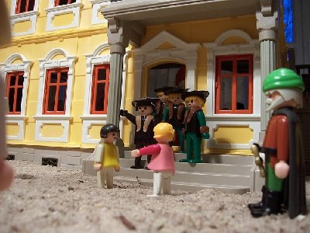
___________________________________________________

___________________________________________________
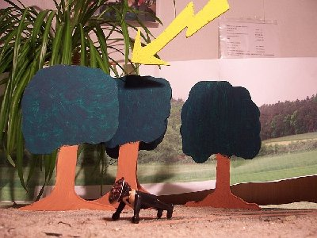
____________________________________________________

____________________________________________________

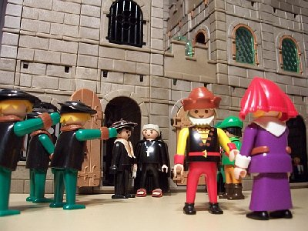
____________________________________________________

____________________________________________________

____________________________________________________
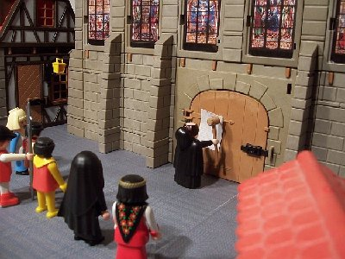
____________________________________________________

____________________________________________________
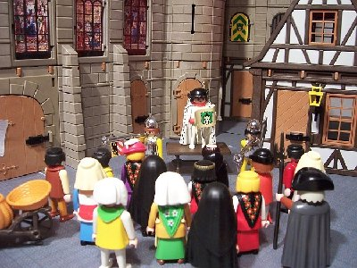
___________________________________________________

___________________________________________________
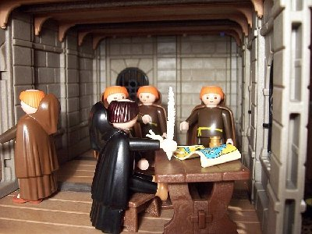
____________________________________________________

____________________________________________________
Luther Rose
3.5

