**Das Kirchenjahr – unsere Feste**

C:\Program Files (x86)\Picto Selector\png\Mulberry Symbol Set\Advent.wmf **Advent**

**__________________________________________________________________**

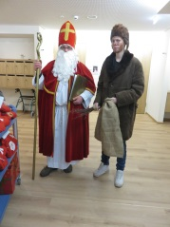 **Nikolaus 6. Dezember**

**__________________________________________________________________**

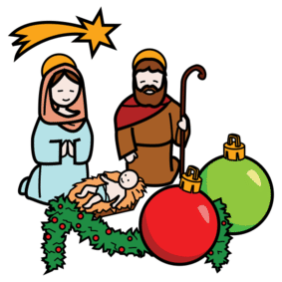 **Weihnachten 24./25./26. Dezember**

**__________________________________________________________________**

** Silvester/Neujahr 31. Dezember/ 1. Januar**

**__________________________________________________________________**

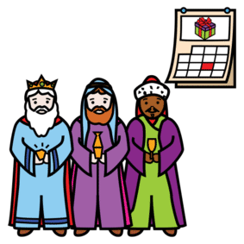 **Drei Könige 6. Januar**

**__________________________________________________________________**

**C:\Program Files (x86)\Picto Selector\png\Mulberry Symbol Set\Palm Sunday.wmf Palmsonntag**

**__________________________________________________________________**

**C:\Program Files (x86)\Picto Selector\png\Mulberry Symbol Set\Last Supper.wmf Gründonnerstag**

**__________________________________________________________________**

** Karfreitag**

**__________________________________________________________________**

**C:\Program Files (x86)\Picto Selector\png\Mulberry Symbol Set\risen.wmf Ostern**

**__________________________________________________________________**

** Pfingsten**

**__________________________________________________________________**

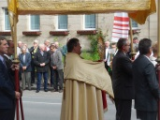 **Fronleichnam**

**C:\Program Files (x86)\Picto Selector\png\Mulberry Symbol Set\Mary.wmf Marias Aufnahme in den Himmel 15. August**

**__________________________________________________________________**

** Erntedank 1. Sonntag im Oktober**

**__________________________________________________________________**

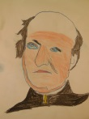 **Regens Wagner 10. Oktober**

**__________________________________________________________________**

**r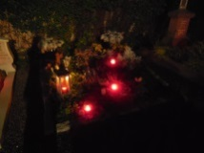 Allerheiligen 1. November**

**__________________________________________________________________**

** 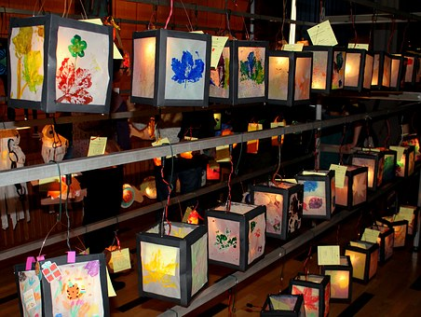 St. Martin 11. November**

**__________________________________________________________________**

**C:\Program Files (x86)\Picto Selector\png\Mulberry Symbol Set\rose.wmf  Hl. Elisabeth 19.November**