3. Jesu Geburt und Kindheit
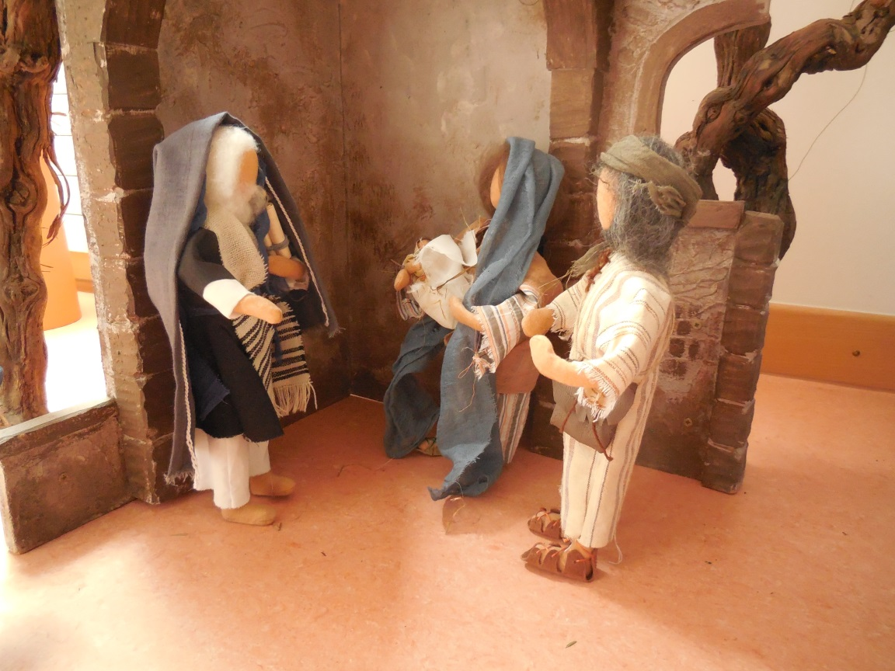

Der Lobpreis des Simeon:

________________________________________________________________________________________________________________________________________________________________________________________________________________________________________________________________________________

